

WHY PLAY IN THE ASHL?

PLAYER’S BENCH:
Our award-winning player management tool enhances your experience.
ASHL experience anytime you’re not on the ice.

EASY REGISTRATION:
Get on the ice faster with online, secure payments via PayPal and more.
Pay in full prior to your first game and receive $250 off your fees

REAL-TIME GAME DATA:
Statistics, scheduling, standings, player attendance tracking – all in real time.
Manage your team like never before!

REWARDS PROGRAM:
The only hockey league with a true rewards program.
Earn Puck Bucks & pay down your league fees!

LEAGUE SCHEDULE AND DIVISIONS:
Whether you’re new hockey or you’ve been playing all your life,
chances are we’ve got the right division for you. You might wonder
how we tier our divisions by skill, and we’d be happy to give you an
overview of how teams are structured within. Each division has its own
preferred days of the week as seen in the table below:
1-Division Types
Division | Levels | Days of the week
Division B | Canadian University OR NCAA | Tuesdays
Division C | Junior B/C, Rep AAA, Rep AA, or Rep A | Wednedays
Division B | Men and women’s teams (less competitive | Sundays
Division A | Men and women’s teams (more competitive than B) | Saturdays
Division E | No formal experience as a hockey player | Fridays
Division A | Professional or Semi professional | Mondays
Division D | Select league or House league | Thursdays

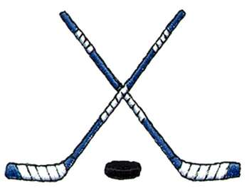
Places to Play:

Structure

Format: 5-on-5 + goalies
Rosters: No roster restrictions will be in place for the Winter ’21/22 season
USA Hockey: All participants are required to register with a valid USA Hockey ID
Team Registration: $6,785.00
Deposit: $1,000.00
Pay in full prior to your first game and receive $250 off your team fees.

